1. Test management systems.

Test management systems help to plan tasks, create schedules, allocate resources, monitor the performance of each specialist and the entire team.

The systems are all structured and clearly see the timing of each task and its implementation. The systems can predict and model risks, calculate the timing of the project when a number of conditions set by variables change. For example, to determine the likelihood of completion of the project when the budget is reduced by 30%, the replacement of several employees or the exclusion of a number of tasks.

It is also an undeniable fact that, for example in the "Trello" system, it is possible to set reminders for each task card and indicate when it should be triggered. At a specified date and time, the specialist will receive an email with a link to the card to which he is attached, and information about when he needs to close the task. This eliminates the fact that due to a heavy workload, the specialist can forget about the task and break deadlines.

2.

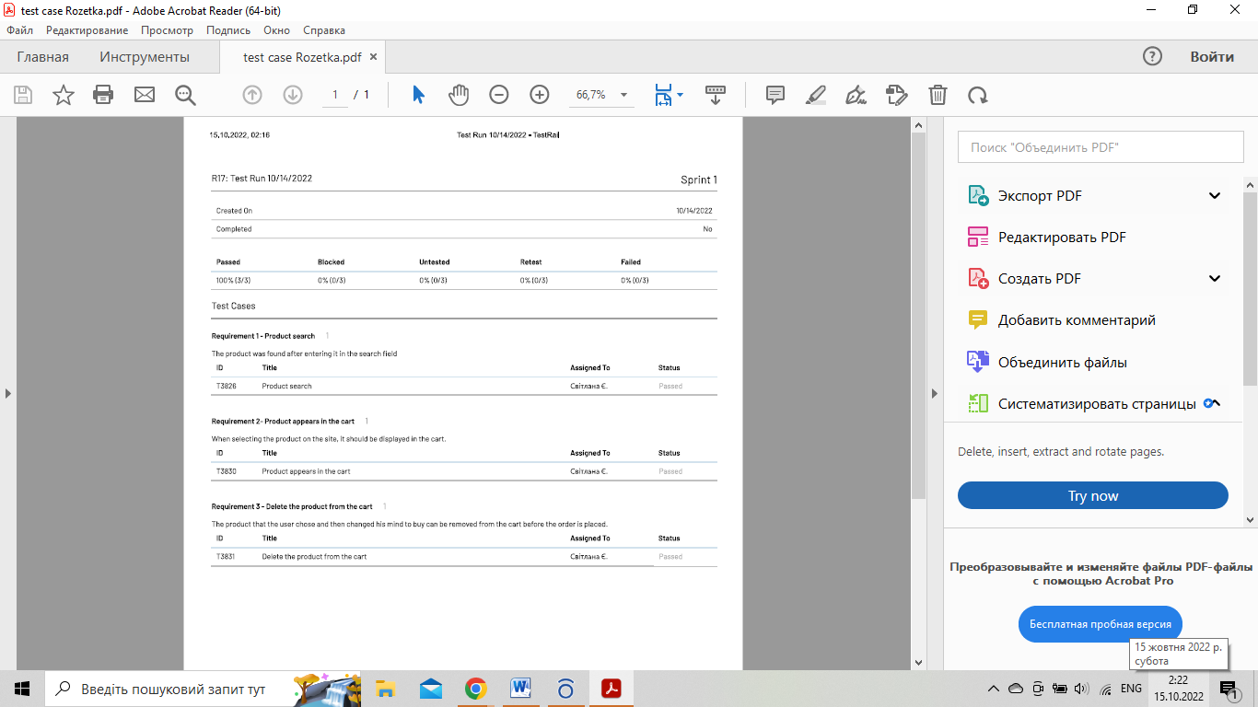

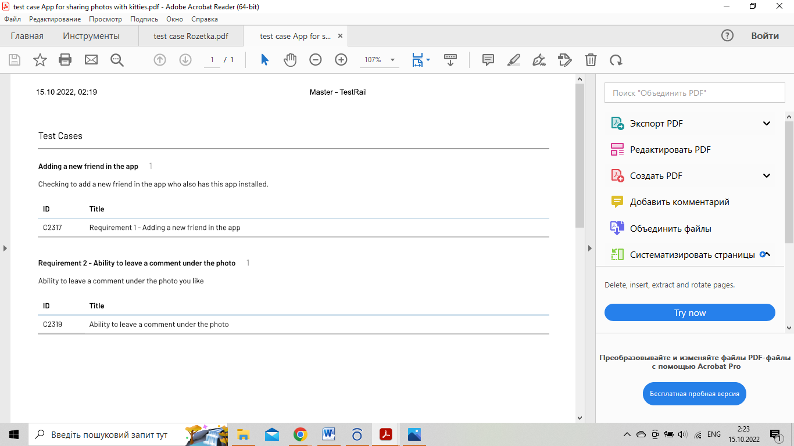

3. Azure DevOps and TestRail

Azure DevOps and TestRail are tools with modules that help organize the QA testing process.

Azure DevOps is a service for teams to share code, track work, and ship software. It provides a flexible, extensible and feature-rich platform for continuous integration, agile planning, and continuous delivery to cover the full development life-cycle. In relation to QA testing, it integrates a module named Test Plan that provides all the tools needed to successfully create and run tests.

Azure DevOps doesn’t surpass TestRail in terms of intuitiveness, user-friendliness, or ease of use.

Free trial 30 days, then the price of $52/month per user. If we have 10 employees on our team, we have to pay $520 a month.

TestRail is an efficient tool designed for QA and development teams to manage, track and organize their software testing effort. It’s an intuitive web-based user interface that is incredibly user-friendly and easy to use, making the creation of test cases, managing test runs and coordinating your entire testing process.

The main limitation is that it's difficult to link manual test cases and automated tests and limited transparency, since only the QA department has access to the documentation.

Free trial 14 days, then the price of $37/month per user. If we have 10 employees on our team, we have to pay $370 a month.